250 grams Super premium White Nest 5A

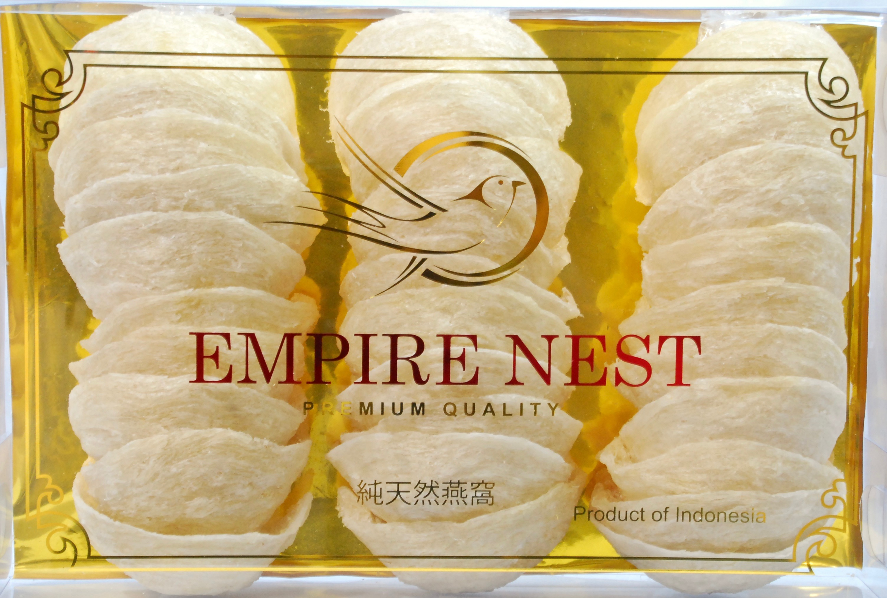

250 grams Super premium White Nest A

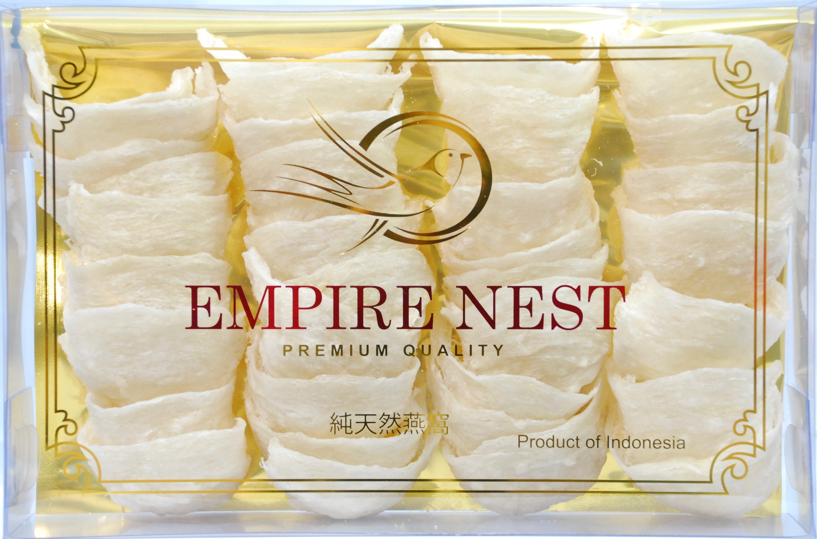

250 grams Super premium White Nest AA

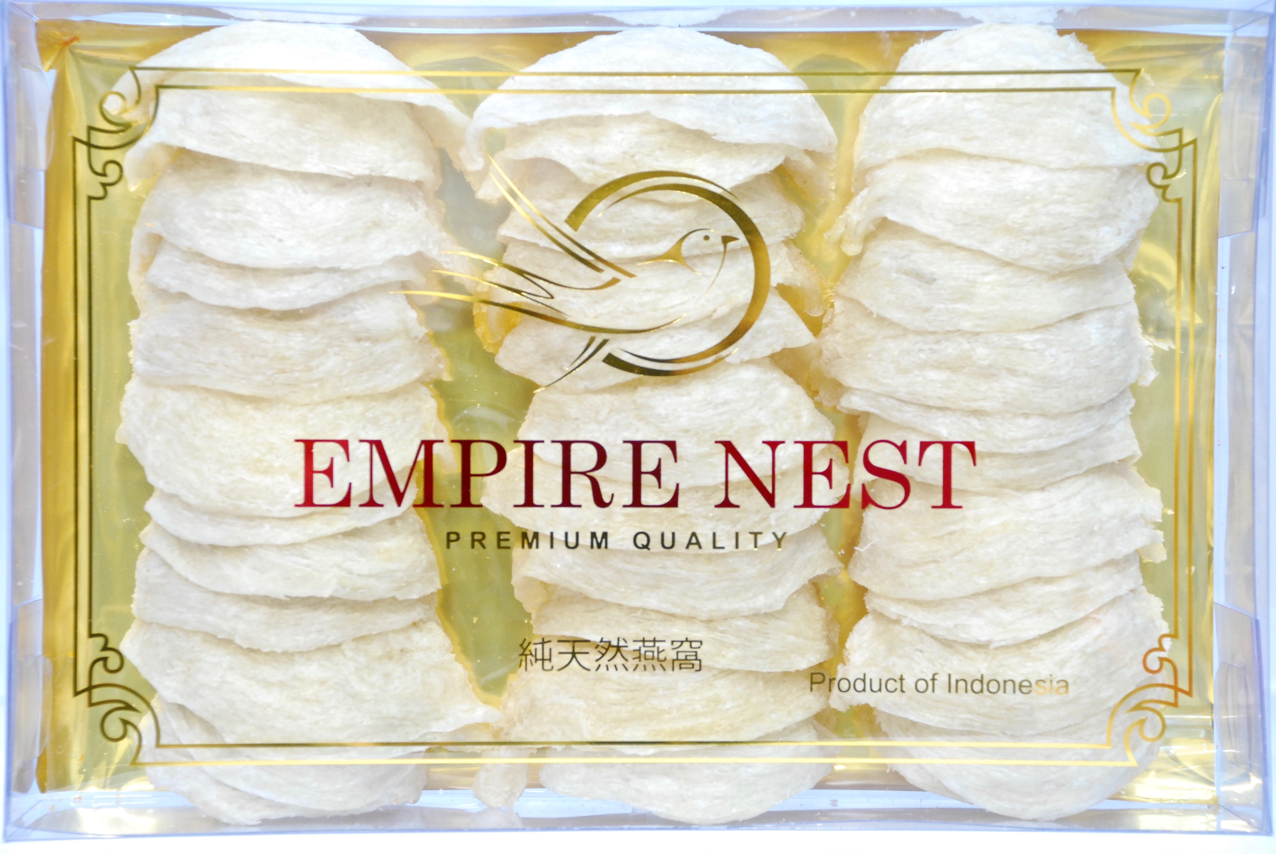

250 grams Super premium White Nest AAA

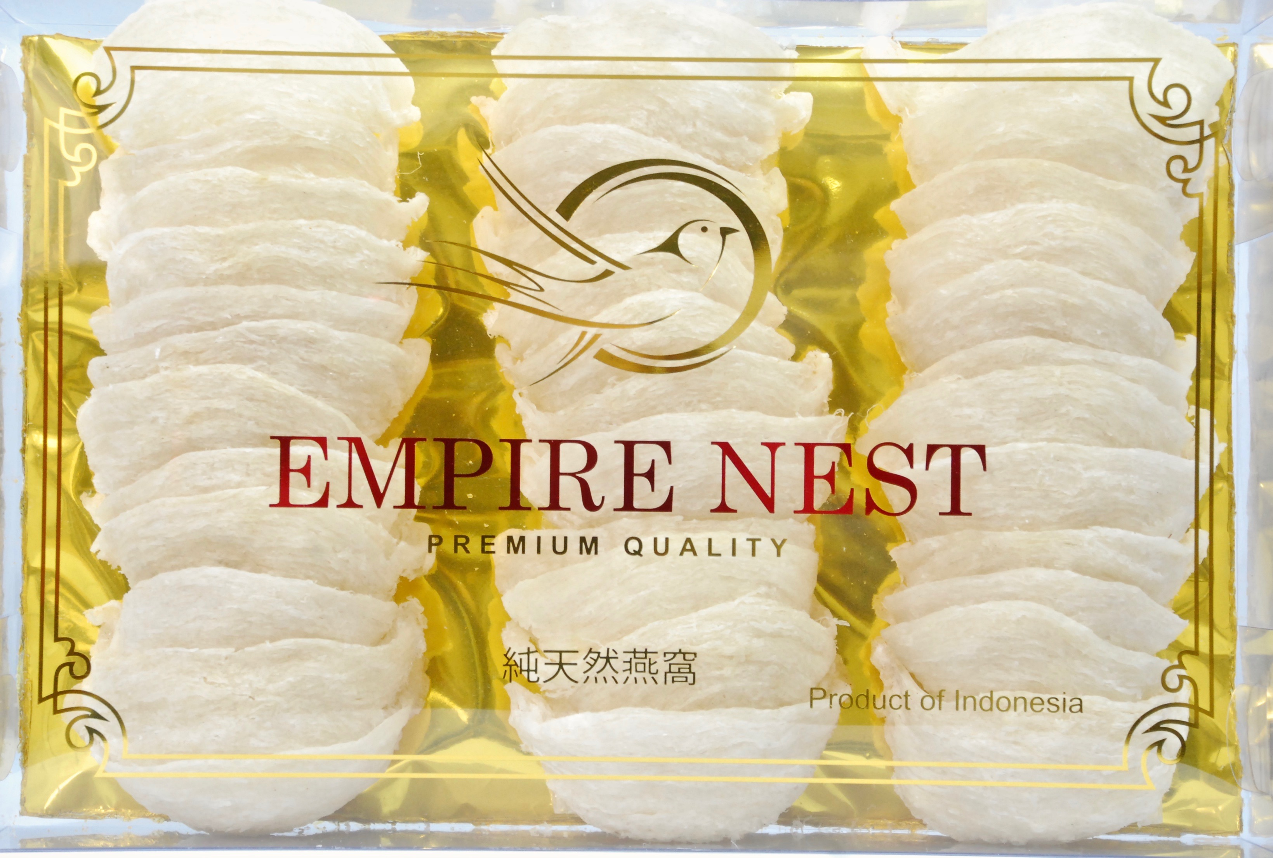

250 grams Super premium White Nest AAAA

